|  |
| --- |
| SWINBURNE UNIVERSITY OF TECHNOLOGY |
| LAB 08 |
| COS10004 – Computer System |
|  |
| **NGO CONG THANH** |
| **11/14/2021** |

|  |
| --- |
| SWINBURNE UNIVERSITY OF TECHNOLOGY |

Insert the error message into your submission document

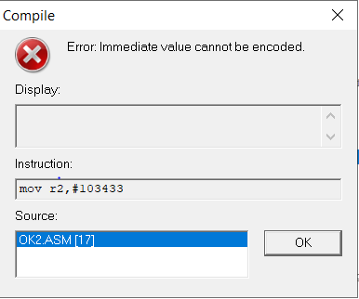

7. Convert your student number to Hex, and enter it in your submission document.

#103433 = $19409

8.1. Why does MOV only work with numbers with 24 bits set to 0?

Because in that 24 bits, there are 20 bits for op-code, 4 left is for a the ROR. These 24 bits use for barrel shifter. Only 8 bits contains value that need to move.

8.2. How can MOV still be used for numbers that do not satisfy this?

We have 64bit and 84bit mov instructions that can use more bits to store the number value to move.

8.3

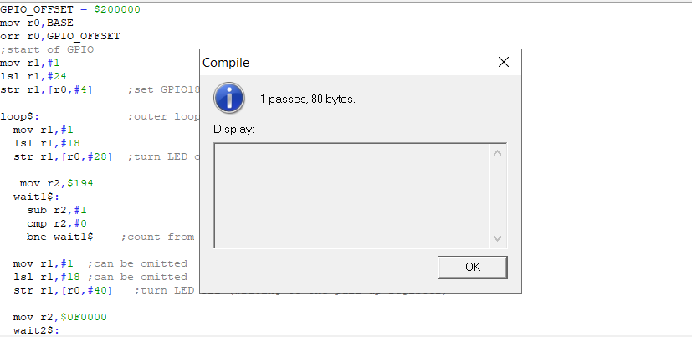

Include your notes or comments in your submission document:

+ Add r2 and assign binary

+ Finish one outer loop, r2-1

+ add timer loop outside outer loop(timerloop3)

+ if r2 = 0 , go to timerloop3

Demonstrate your program to your lab demonstrator and copy your code into your submission document:

format binary as 'img' ;must be first

BASE = $FE000000 ; Use $3F000000 for 2B, 3B, 3B+

GPIO_OFFSET = $200000

mov r0,BASE

orr r0,GPIO_OFFSET ;Base address of GPIO

mov r1,#1

lsl r1,#24; GPIO18

str r1,[r0,#4] ;enable output

mov r1,#1

lsl r1,#18

mov r8,BASE

orr r8,TIMER_OFFSET ;store base address of timer (r3)

mov r9,$2D0000

orr r9,$00C600

orr r9,$0000C0 ;TIMER_MICROSECONDS = 3 second

timerloop3:

mov r2,#11

loop$:

str r1,[r0,#28] ;Turn on LED

;new timer

TIMER_OFFSET = $3000

;TIMER_MICROSECONDS = 524288 ; $0080000 ;0.524288 s

mov r3,BASE

orr r3,TIMER_OFFSET ;store base address of timer (r3)

mov r4,$70000

orr r4,$0A100

orr r4,$00020 ;TIMER_MICROSECONDS = 500,000

;store delay (r4)

ldrd r6,r7,[r3,#4]

mov r5,r6 ;store starttime (r5)(=currenttime (r6))

timerloop:

ldrd r6,r7,[r3,#4] ;read currenttime (r6)

sub r8,r6,r5 ;remainingtime (8)= currenttime (r6) - starttime (r5)

cmp r8,r4 ;compare remainingtime (r8), delay (r4)

bls timerloop ;loop if LE (reaminingtime <= delay)

str r1,[r0,#40] ;turn off LED

;re-use timer

ldrd r6,r7,[r3,#4]

mov r5,r6 ;store starttime (r5)(=currenttime (r6))

timerloop2:

ldrd r6,r7,[r3,#4] ;read currenttime (r6)

sub r8,r6,r5 ;remainingtime (8)= currenttime (r6) - starttime (r5)

cmp r8,r4 ;compare remainingtime (r8), delay (r4)

bls timerloop2 ;loop if LE (reaminingtime <= delay)

sub r2,r2,#1

b loop$

cmp r2,#0

beq timerloop3

